11.18: a) Denote the length of the boom by L, and take torques about the pivot point. The tension in the guy wire is found from

so 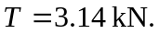 The vertical force exerted on the boom by the pivot is the sum of the weights, 7.06 kN and the horizontal force is the tension, 3.14 kN. b) No;